Week 2 OOP-Java practice

Programs to practice :

1. Name concadenation

Prgm 1 Name( string datatype)

import java.io.\*;

public class Name{

public static void main(String[] args){

String name1="Ben";

String name2="Dover";

String namef=name1+name2;

System.out.println(namef);

}

}

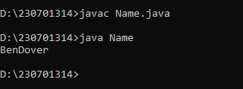

1. Datatypes of java

public class datatypes{

public static void main(String[] args) {

int num = 5;

float floatNum = 5.99f;

double D= 33.823;

char C = 'D';

boolean bool = true;

String text = "Hello";

System.out.println("integer datatype : "+num);

System.out.println("double datatype : "+D);

System.out.println("float datatype : "+floatNum);

System.out.println("character datatype : "+C);

System.out.println("boolean datatype : "+bool);

System.out.println("String datatype : "+text);

}

}

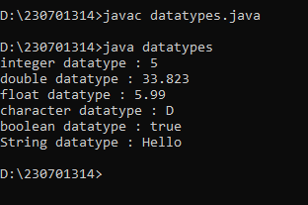

1. Typecasting in java (manual)

Progm 2 typecasting(double to int)

import java.io.\*;

public class typecasting{

public static void main(String[] args){

double d1=30.13;

int doubint=(int) d1;

System.out.println("original double value is : "+d1);

System.out.println("typecasted value is : "+doubint);

}

}

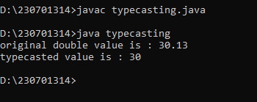

4) arithmetic operations

public class arithmetic{

public static void main(String[] args){

int a=41;

int b=53;

System.out.println("the numbers being calculated are: \n a= "+a+"\nb= "+b);

int add=a+b;

int sub=b-a;

int mul=a\*b;

float div=b/a;

System.out.println("ADDITION = "+add+"\nSUBTRACTION = "+sub+"\nMULTIPLICATION = "+mul+"\nDIVISON = "+div);

}

}

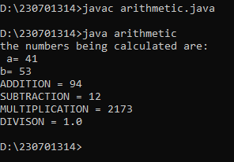

5. registerations

public class registerations{

public static void main(String[] args){

String name="Siddarth";

long number= 9867564321L;

String mail="mynbi@example.com";

System.out.println("Name: "+name);

System.out.println("Number: "+number);

System.out.println("Mail: "+mail);

}

}

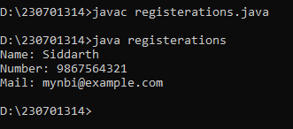

6)

public class qnr{

public static void main(String[] args){

int a=355;

int b=4;

int quotient=a/b;

int remainder=a%b;

System.out.println("The quotient for a = "+a+" and b= "+b+" is : "+quotient+" \nand the remainder is : "+remainder);

}

}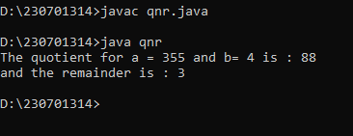

7)

public class Swap{

public static void main(String[] args){

int a=364;

int b=45;

System.out.println("initially a = "+a+" and b = "+b+"\n");

int temp= a;

a=b;

b=temp;

System.out.println("after swapping:\na= "+a+"\n"+"b= "+b);

}

}’

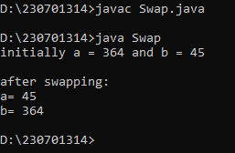

8) square

public class Square{

public static void main(String[] args){

int a=35;

System.out.println("the square of a: "+a+"\nis : "+Math.pow(a,2));

}

}

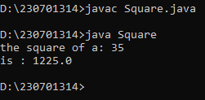

9)float pro

public class floatpro {

public static void main(String[] args) {

float first = 1.5f;

float second = 2.0f;

float product = first \* second;

System.out.println("The product is: " + product);

}

} 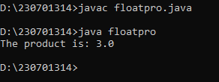

10) floatsum

public class floatsum {

public static void main(String[] args) {

float first = 1.5f;

float second = 2.0f;

float product = first + second;

System.out.println("The product is: " + product);

}

}

